Fall 2019 Newsletter #3  CASA Rental Management  RESIDENTIAL TENANCY BRANCH RENT INCREASE FOR 2020  The rent increase limit for 2020 is 2.6%, marking the seventh straight year that rents can be increased.  Fall Maintenance is being scheduled  Your Property Manager will be arranging the interior and exterior fall maintenance for your property in the next few months  REPAIRS  Fall/ Winter are generally the time when repairs are the greatest. Landlords on behalf of the Owner must perform any maintenance work that is necessary for keeping the rental unit livable for the tenant. The owner is also legally responsible for repairing any defects. According to section 32(1) of the Residential Tenancy Act (RTA) rental properties must comply with health, safety, and housing standards required by law, landlords/owners are generally responsible for the following repair and maintenance issues:  - heating  - plumbing  - electricity  - smoke detectors  - routine yard maintenance, such as cutting grass, clearing snow in multi -unit residential complexes  - Infestations, pests such as bedbugs |  | 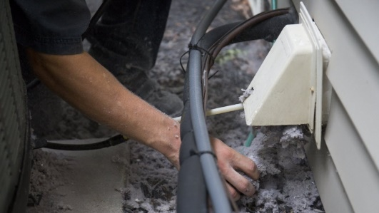  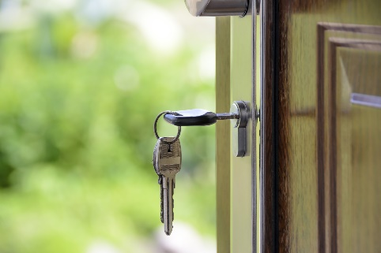  CASA Rental Management is updated our records.  Please fill out the attached fillable form with your current contact information and emergency contact information and return to your property manager as soon as possible.  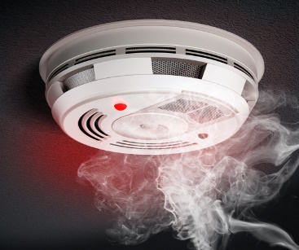

Wear and tear vs Tenant damage  Typically, landlords may use a tenant's security deposit for any cleaning or repairs necessary to restore the rental unit to its condition at the beginning of the tenancy. Landlords MAY NOT, however, use the deposit to cover the costs of ordinary wear and tear. (The longer a tenant has lived in a property, the more wear and tear can be expected.) Here are just a few examples of ordinary wear and tear versus tenant-created issues.  Ordinary wear and tear Possible Tenant responsibility  Curtains faded by the sun Ripped curtains  Linoleum stains/shower spray Broken bathroom tiles  Minor marks or wall nicks Large marks or giant holes  Dents in wall from handles Door off its hinges  Moderate dirt or carpet spots Rips in carpet or pet stains  A few small tack or nail holes Lots of picture holes, wall gouges  A rug worn thin by normal use Stains in rug from plant leaks  Worn gaskets or fridge doors Broken fridge shelves  Faded wall paint Writing on walls  Dark patched of dirt on hardwood floors that have lost their finish Water stains of floor from windows left open for long periods of time  Warped cabinet doors Sticky cabinets and interiors  Stains on old porcelain fixtures that have lost its protective coating Grime coated bathtub and toilet  Moderately dirty mini blinds Missing mini blinds  Bathroom mirror black spots, deterioration Dirty mirrors caked with dirt  Clothes dryer that delivers cold air- broken thermostat Dryer that won’t turn on because of overloading  Toilet flushes inadequately because of mineral deposit clogs Toilet won’t flush because of debris flushed in error  Please be aware that there will ALWAYS be wear and tear when any property is occupied. Most tenants do treat their properties as their family home. |  | “Recommend a friend”  Many of our properties are recommended to us by our existing property Owners. To show our gratitude we have launched our “Recommend a Friend” program.  Recommend CASA Rental Management to a family member, friend, or colleague, and they become a member of our portfolio, we will say thank you with a $100 gift card!  CASA  Rental Management  Samantha 604-445-8769  samantha@casarentals.ca  Nikki - 604-445-8767  nikki@casarentals.ca  Brad - 604-445-8763  brad@casarentals.ca  110 - 6086 Russ Baker Way  Richmond BC, V7C1Z2  604-273-6801 info@casarentals.ca

